# Brainstorm

**TIP**

You can select a sticky note and hit the pencil [switch to sketch] icon to start drawing!

## Before you collaborate

A little bit of preparation goes a long way with this session. Here’s what you need to do to get going.

**10 minutes**

**1**

## Define your problem statement

What problem are you trying to solve? Frame your problem as a How Might We statement. This will be the focus of your brainstorm.

**5 minutes**

**2**

## Brainstorm

Write down any ideas that come to mind that address your problem statement.

**10 minutes**

**3**

## Group ideas

Take turns sharing your ideas while clustering similar or related notes as you go. Once all sticky notes have been grouped, give each cluster a sentence-like label. If a cluster is bigger than six sticky notes, try and see if you and break it up into smaller sub-groups.

**20 minutes**

**4**

## Prioritize

Your team should all be on the same page about what's important moving forward. Place your ideas on this grid to determine which ideas are important and which are feasible.

**20 minutes**

## After you collaborate

You can export the mural as an image or pdf to share with members of your company who might find it helpful.

**Quick add-ons**

# & idea prioritization

**TIP**

Add customizable tags to sticky notes to make it easier to find, browse, organize, and categorize important ideas as themes within your mural.

**PROBLEM**

**How might we perform analytics on hospital's health care data?**

|  |  |
| --- | --- |
| Enable automation of processes | Find cost effective ways |
|  |  |
| Get inference from the data | Maintain reliability |

Use this template in your own brainstorming sessions so your team can unleash their imagination and start shaping concepts even if you're not sitting in the same room.

1. **Team gathering**

Define who should participate in the session and send an invite. Share relevant information or pre-work ahead.

1. **Set the goal**

Think about the problem you'll be focusing on solving in the brainstorming session.

1. **Learn how to use the facilitation tools**

Use the Facilitation Superpowers to run a happy and

**Lanaard**

Understand the data available

Find ways to handle large amount of data

Perform survey to know about patient needs

Avoid any error in data

Understand patient needs

List the ways of analysis

**Joshua**

Gather required data

Consider customer satisfaction

**Nandakumar**

Get inference from data available

|  |  |
| --- | --- |
| Find |  |
| effective | Understand |
| analytics | user needs |
| methods |  |
|  |  |
| Understand use of various | Ensure high |
| visualization methods | reliability |

Understand user problems

**Ragavan**

Find a optimal solution for gaining insight

Understand need for analytics

|  |  |
| --- | --- |
| Ensure high accuracy is reached | Perform pre processing of data if needed |
|  |  |
| Understand impacts of the results | Determine the format of the output |

1. **Share the mural**

**Share a view link** to the mural with stakeholders to keep them in the loop about the outcomes of the session.

1. **Export the mural**

Export a copy of the mural as a PNG or PDF to attach to emails, include in slides, or save in your drive.

**10 minutes** to prepare

**1 hour** to collaborate

**2-8 people** recommended

productive session.

[**Open article**](https://support.mural.co/en/articles/2113740-facilitation-superpowers)

### Key rules of brainstorming

To run an smooth and productive session

### Keep moving forward

**Strategy blueprint**

Define the components of a new idea or strategy.

[**Open the template**](https://app.mural.co/template/e95f612a-f72a-4772-bc48-545aaa04e0c9/984865a6-0a96-4472-a48d-47639307b3ca)

**Customer experience journey map**

Stay in topic. Defer judgment.

Encourage wild ideas. Listen to others.

### Importance

If each of these

Understand customer needs, motivations, and obstacles for an experience.

[**Open the template**](https://app.mural.co/template/b7114010-3a67-4d63-a51d-6f2cedc9633f/c1b465ab-57af-4624-8faf-ebb312edc0eb)

|  |  |  |  |  |  |  |
| --- | --- | --- | --- | --- | --- | --- |
|  | | | | | | |
|  |  |  |  |  |  |  |
|  |  |  |  |  |  |
|  |  |  |  |  |  |
|  |  |  |  |  |  |
|  |  |  |  |  |  |
|  |  |  |  |  |  |

[**Share template feedback**](https://muralco.typeform.com/to/CiqaHVat?typeform-source=app.mural.co)

Go for volume. If possible, be visual.

tasks could get

done without any difficulty or cost, which would have the most positive impact?

### Feasibility

Regardless of their importance, which tasks are more feasible than others? (Cost, time, effort, complexity, etc.)

**Strengths, weaknesses, opportunities & threats**

Identify strengths, weaknesses, opportunities, and threats (SWOT) to develop a plan.

|  |  |
| --- | --- |
|  |  |
|  |  |

[**Open the template**](https://app.mural.co/template/6a062671-89ee-4b76-9409-2603d8b098be/ca270343-1d54-4952-9d8c-fbc303ffd0f2)

[**Share template feedback**](https://muralco.typeform.com/to/CiqaHVat?typeform-source=app.mural.co)

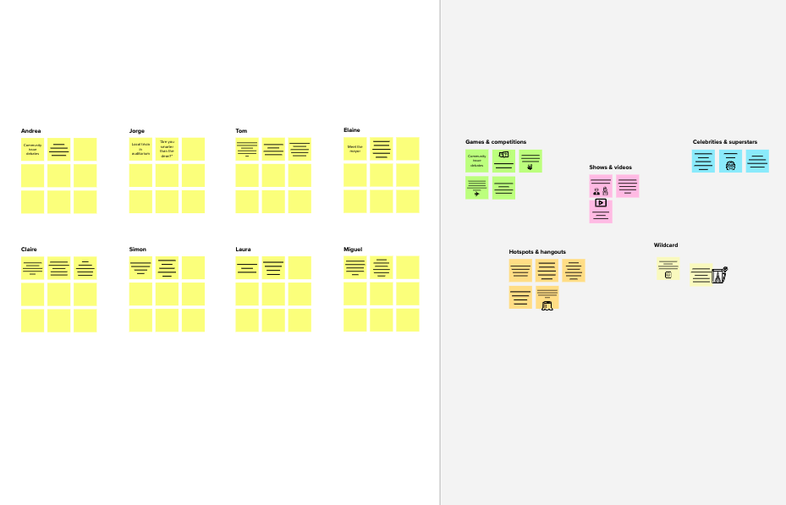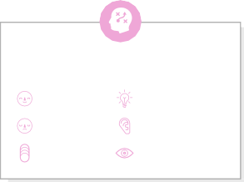

**Template**

**Need some inspiration?**

See a finished version of this template to kickstart your work.

[**Open example**](https://app.mural.co/template/e5a93b7b-49f2-48c9-afd7-a635d860eba6/93f1b98d-b2d2-4695-8e85-7e9c0d2fd9b9)